Xuan Thuy Criteria: A1, A4i & A4iii

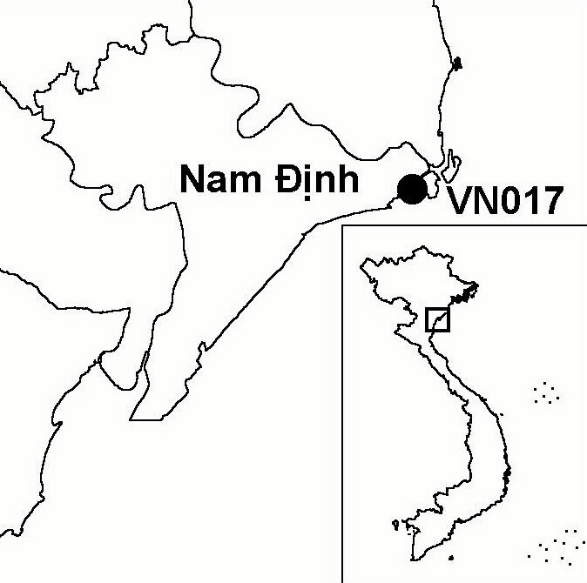
Province(s): Nam Dinh
PA Status: Nature Reserve

Latitude: 20º13'N
Longitude: 106º33'E
Area: 12,000 ha
Altitude Range: 0-3 m asl

EBA / SA:

None
Priority Landscape:
None

General Description

The IBA comprises Xuan Thuy Ramsar site, which is situated in the coastal zone of the Red River Delta, to the south of the mouth of the main channel of the Red River. Due to its location, there is a high rate of sediment deposition at the IBA, forming large intertidal mudflats, which are important habitats for migratory waterbirds. In addition to the intertidal mudflats, there are three large islands at the IBA: Con Ngan, Con Lu and Con Xanh. Con Ngan, the largest island, supports a large area of mangrove, which has almost entirely been enclosed within aquacultural ponds. Con Lu, a large, sandy island, supports coastal marshes and plantations of the exotic Casuarina equisetifolia. Con Xanh, the smallest island, is a thin sandy island, still increasing in size due to sediment deposition.

Bird Fauna: Key Features

Xuan Thuy is the most important staging and wintering area for migratory waterbirds in the coastal zone of the Red River Delta. During surveys in 1988 and 1994, more than 20,000 waterbirds were observed^{1,2}. During the spring of 1996, it was estimated that 33,000 shorebirds passed through the IBA³. The IBA regularly supports over 1% of the biogeographic population of a number of commoner migratory waterbird species, including Black-tailed Godwit Limosa limosa, Spotted Redshank Tringa erythropus and Eurasian Curlew Numenius arquata. In addition, the IBA supports nationally significant wintering populations of Heuglin's Gull Larus heuglini and Black-headed Gull L. ridibundus. However, it is for regularly supporting significant numbers of globally threatened and near-threatened waterbird species that the IBA is most notable. Xuan Thuy supports the largest wintering population of Black-faced Spoonbill Platalea minor in Vietnam, with around 50 birds each winter in recent years. In addition, the IBA supports significant wintering populations of Saunders's Gull Larus saundersi, Spotted Greenshank Tringa guttifer and Spoon-billed Sandpiper Eurynorhynchus pygmeus. Furthermore, over 1% of the biogeographic population of Asian Dowitcher Limnodromus semipalmatus regularly uses the IBA as a staging ground. Finally, Xuan Thuy is an important site for non-waterbird migration, with large numbers of passerines, cuckoos and other birds passing through the IBA during the spring and autumn migrations.

Species | IBA  Criteria | Global Threat Status | Other  IBAs | Notes
Spotted Greenshank  Tringa guttifer | A1, A4i | EN | 3 | The species is a regular winter visitor in small numbers, with maximum counts of five birds in the winter of 1993/1994, two in 1994/1995, 14 in 1995/1996, six in 1996/1997, 28 in 1997/1998, three in 1998/1999 and 10 in 1999/2000^{2,3,4,5}.
Black-faced Spoonbill  Platalea minor | A1, A4i | EN | 8 | The species is a regular winter visitor, with maximum counts of 25 birds in the winter of 1993/1994, 34 in 1994/1995, 75 in 1995/1996, 42 in 1996/1997, 30 in 1997/1998, 20 in 1998/1999, 55 in 1999/2000, 47 in 2000/2001 and 65 in 2001/2002^{2,3,5}.
†Baer's Pochard  Aythya baeri | A1 | VU | 0 | The species is a very rare winter visitor to the site. The only recent records are of a flock of six seen in December 1996⁵ and a single bird seen in December 2001⁶. It is unlikely that the site regularly supports significant numbers of this species.
Spoon-billed Sandpiper  Eurynorhynchus pygmeus | A1 | VU | 3 | The species is a regular winter visitor in small numbers, with maximum counts of two birds in the winter of 1993/1994, one in 1994/1995, 15 in 1995/1996, 27 in 1996/1997, 10 in 1997/1998, six in 1998/1999, four in 1999/2000, two in 2000/2001 and six in 2001/2002^{2,3,5}.
Saunder's Gull  Larus saundersi | A1, A4i | VU | 5 | The species is a regular winter visitor, with maximum counts of 30 birds in the winter of 1993/1994, 28 in 1994/1995, over 100 in 1995/1996, 77 in 1996/1997, 34 in 1997/1998, 30 in 1998/1999, 50 in 1999/2000 and three in 2001/2002^{2,3,5,7}. However, the highest single count was of around 200 birds in March 1988¹.
Chinese Egret  Egretta eulophotes | A1 | VU | 6 | The species is a rare passage migrant, with one or two birds being seen most years⁵. The species also appears to be a very rare winter visitor, with a single record of two birds from December 2001⁶.
Spot-billed Pelican  Pelecanus philippensis | A1 | VU | 6 | This species is a non-breeding visitor to the site in small numbers. The species occurs most years, with the highest count to date being five birds in August 1994².
†Fairy Pitta  Pitta nympha | A1, A3 | VU | 2 | The species is a rare passage migrant, and is only known from a single record in September 1999⁵. It is unlikely that the site regularly supports a significant population.
†Manchurian Reed Warbler  Acrocephalus tangorum | A1 | VU | 0 | The species appears to be a rare passage migrant. To date, there have been only two confirmed records from the site: one or two birds in October 1997 and one bird in October 2000^{5,8}. Although it is possible that this species may have been overlooked during previous surveys, it is unlikely that the site regularly supports significant numbers.
†Far Eastern Curlew  Numenius madagascariensis | A1 | NT | 4 | Single birds were recorded in October 1997 and January 2000⁵. It is unlikely that the site regularly supports significant numbers of this species.
Asian Dowitcher  Limnodromus semipalmatus | A1, A4i | NT | 5 | The species is a regular passage migrant, with maximum counts of 165 birds in the winter of 1993/1994, 181 in 1994/1995, 35 in 1995/1996, 20 in 1996/1997, three in 1997/1998, two in 1998/1999, eight in 1999/2000 and six in 2000/2001^{2,3,5}.
†Black-headed Ibis  Threskiornis melanocephalus | A1 | NT | 8 | A single bird was observed in August 2001⁵. It is unlikely that the site regularly supports a significant population of this species.
Painted Stork  Mycteria leucocephala | A1 | NT | 10 | The species is a regular non-breeding visitor, with between 13 and 30 birds recorded each year^{2,5}. The most recent record was of 17 birds in September 2001⁵.
Black-tailed Godwit  Limosa limosa | A4i |  | 1 | The species is a regular winter visitor in large numbers, with a largest count to date of around 5,000 individuals in April 1996³.
Eurasian Curlew  Numenius arquata | A4i |  | 1 | The species is a regular winter visitor, with a largest count to date of 900 birds in November 1997⁹.
Spotted Redshank  Tringa erythropus | A4i |  | 2 | The species is a regular winter visitor in large numbers, with a largest count to date of 1,500 birds in March 1988¹.
Grey-tailed Tattler  Heteroscelus brevipes | A4i |  | 0 | The species is a regular passage migrant, with a largest count to date of 1,000 birds in May 1997⁹.
Dunlin  Calidris alpina | A4i |  | 0 | The species is a regular winter visitor, with a largest count to date of 1,500 in February 1995⁹.

Notes: † = not confirmed to regularly occur in significant numbers.

Biome Restricted Species: The site does not qualify under criterion A3. See Appendix 4 for details.

Secondary Criteria

The site does not qualify under any secondary criterion.

Threats to Biodiversity

The greatest threat to biodiversity at Xuan Thuy is habitat loss. Mangrove afforestation is taking place on the intertidal mudflats, with the objectives of land reclamation and foreshore protection. This is changing the nature of the substrate, and threatening to make these areas unsuitable for Black-faced Spoonbill, Saunders's Gull, Spoon-billed Sandpiper and other bird species for which intertidal mudflats are the preferred feeding habitat¹⁰. The low counts of these species in recent years are surely a reflection of the consequences of afforestation⁹. Additionally, on Con Ngan, aquacultural intensification is leading to die-back of emergent vegetation, and the loss of roosting habitats for a range of bird species. Furthermore, sandy islands, which support dune and saltmarsh vegetation, are being afforested with the exotic Casuarina equisetifolia¹¹. Finally, Xuan Thuy once supported one of the largest reedbeds in Vietnam, which seasonally supported large numbers of roosting Eurasian Marsh Harriers Circus aeruginosus and Pied Harriers C. melanoleucos, as well as reed swamp species, such as Purple Heron Ardea purpurea. However, this reedbed has since been cleared, as a result of agricultural and aquacultural intensification⁹.

During the early 1990s, hunting was a major threat to bird populations at Xuan Thuy. During the 1990s, numbers of Greylag Geese Anser anser and ducks wintering at Xuan Thuy decreased dramatically⁹. However, since the establishment of a nature reserve at the site, hunting levels have declined significantly. Unfortunately, large areas of key habitat for migratory shorebirds lie outside the nature reserve boundary, and birds using these areas are still exposed to hunting pressure. Of the 12,000 ha Ramsar site, only 7,680 ha are included within the nature reserve. An additional threat derives from the high human population density in the surrounding area, and high levels of human use of the site. Activities such as fishing and shellfish collection in the intertidal zone may disturb the globally threatened bird species, either directly or indirectly¹¹. An additional source of disturbance to birds is the dogs kept by workers at the aquacultural ponds¹⁰.
Threat | Severity
Afforestation | ● ●
Agricultural intensification / expansion | ●
Aquaculture / fisheries | ● ●
Disturbance to birds | ● ●
Hunting | ●
Selective logging / cutting | ●

Conservation Actions

- In 1988, Xuan Thuy was designated as Vietnam's first, and to date only, Ramsar site¹¹.
- The government of Vietnam decreed Xuan Thuy as a nature reserve in 1994¹¹.
- Xuan Thuy is one of the sites included in a proposed medium-sized Global Environment Facility (GEF) project, focussing on conservation of coastal wetlands, currently being developed by the Centre for Natural Resources and Environmental Studies¹¹.
- Since 2001, BirdLife International and the nature reserve management board have been implementing a Keidanren Nature Conservation-funded project to establish an ecological monitoring programme at Xuan Thuy.

Recommendations

- The boundaries of the nature reserve should be revised to incorporate important areas of habitat for migratory waterbirds, including intertidal mudflats to the south-west of Con Lu and aquacultural ponds on Con Ngan.
- There should be no further afforestation of intertidal mudflats with mangrove.
- The responsibilities of the nature reserve management board should be extended to include management of aquaculture and fishing activities at the site. To this end, the management board should be expanded to include members of staff from the district fisheries office.
- A management plan should be developed for the nature reserve, that balances the economic, coastal protection and biodiversity values of different habitat types and promotes environmentally sustainable development.

References

1. Scott, D. A. ed. (1989) A directory of Asian wetlands. Gland: IUCN.
2. Pedersen, A., Nielsen, S., Le Dien Thuy and Le Trong Trai (1998) The status and conservation of threatened and near-threatened species of birds in the Red River Delta, Vietnam. Bird Conservation International 8: 31-51.
3. Pedersen, A. and Nguyen Huy Thang (1996) The conservation of key coastal wetland sites in the Red River Delta. Hanoi: BirdLife International Vietnam Programme.
4. Hornbuckle, J. (1998) Vietnam trip report 24 March to 14 April 1998. Unpublished report posted on the WorldTwitch Website.
5. Eames, J. C. and Tordoff, A. W. (in prep) Recent records and a conservation status review of some threatened and near-threatened bird species in Vietnam.
6. A. Allport in litt. 2002.
7. C. R. Robson in litt. 2002.
8. Birdlife International (2001) Threatened birds of Asia: the Birdlife International Red Data Book. Cambridge, UK: Birdlife International.
9. J. C. Eames personal observations.
10. Yu, Y. T. and Swennen, C. (2001) Is mangrove afforestation destroying Black-faced Spoonbill habitat in the Red River Delta? OBC Bulletin 33: 53-56.
11. BirdLife International and the Forest Inventory and Planning Institute (2001) Sourcebook of existing and proposed protected areas in Vietnam. Hanoi: BirdLife International Vietnam Programme and the Forest Inventory and Planning Institute.

Spoon-billed Sandpiper Eurynorhynchus pygmeus

