Yok Don Criteria: A1, A2 & A3

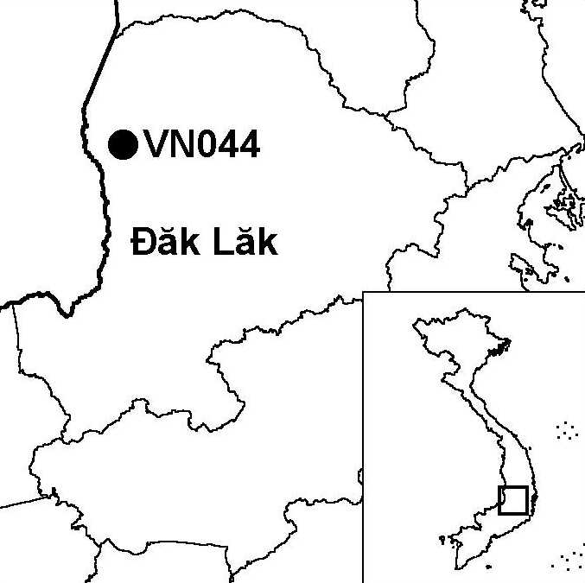
Province(s): Dak Lak
PA Status: National Park

Latitude: 12º54'N
Longitude: 107º40'E
Area: 58,200 ha
Altitude Range: 200-482 m asl

EBA / SA:

None
Priority Landscape:
DF 4 - Eastern Plains Dry Forests

General Description

The IBA is situated in the Mekong basin, on the international border with Cambodia. The boundaries of the IBA follow the original boundaries of Yok Don National Park, prior to its expansion in 2001, except that, unlike the original national park, the IBA includes both banks of the Srepok river. The topography of the IBA is relatively flat, and most areas are around 200 m asl. The highest point in the IBA is Yok Don hill, an isolated ridge, which reaches 482 m asl. The forest cover of the IBA is close to 100%, and is dominated by deciduous forest, although there are also smaller areas of semi-evergreen and evergreen forest, particularly along the Srepok river and on Yok Don hill. The IBA is believed to have once supported significant populations of large mammals, including Asian Elephant Elephas maximus, Brow-antlered Deer Cervus eldii, Gaur Bos gaurus, Banteng B. javanicus and Tiger Panthera tigris. However, most of these species are now much reduced and some may already be locally extinct^{1,2}. To the north, Yok Don IBA is contiguous with Chu M'Lanh IBA, while, to the west, it is contiguous with Upper Srepok Catchment IBA in Cambodia.

Bird Fauna: Key Features

The avifauna of Yok Don IBA is characteristic of the dry forests of central Indochina, with over 20 species restricted to the Indo-Malayan Tropical Dry Zone (Biome 11), including several that are known from few other sites in Vietnam, such as Indian Nightjar Caprimulgus asiaticus and Brown Prinia Prinia polychroa. There are confirmed records of 11 globally threatened and near-threatened bird species from the IBA. One of the key habitats for these species is permanent watercourses, such as the Srepok river. Species dependent on these habitats include Green Peafowl Pavo muticus, Grey-headed and Lesser Fish Eagles Ichthyophaga ichthyaetus and I. humilis, Oriental Darter Anhinga melanogaster and Masked Finfoot Heliopais personata. The latter species is only known to occur at one other site in Vietnam: Kon Cha Rang IBA². A recent study predicted that Yok Don IBA supports 11% of the Green Peafowl population of Dak Lak province. This figure may, however, be an over-estimate, due to the recent spread of human settlement along the north bank of the Srepok river³. The western part of the IBA, close to the international border with Cambodia, has been the focus of relatively little ornithological survey, and may still support relict populations of the critically endangered White-shouldered Ibis Pseudibis davisoni or Giant Ibis Thaumatibis gigantea. However, if a population of either species does occur, it is likely to be very small and extremely susceptible to human pressure².

Species | IBA  Criteria | Global Threat Status | Other  IBAs | Notes
Green Peafowl  Pavo muticus | A1, A3 | VU | 8 | The species is a widespread resident at low densities². A single individual was recorded in May 1997⁴. A total of 10 individuals were recorded between March and April 1998, and the IBA was estimated to support 11% of the population in Dak Lak province³. The most recent records were of birds heard calling near Guard Station No. 5 and along the Dak Klau stream in May 2002².
[Sarus Crane  Grus antigone] | A1 | VU | 5 | There is a single, unconfirmed record based on a report by a forest guard of a nest containing eggs being found on the ground prior to September 1993⁵.
Masked Finfoot  Heliopais personata | A1, A3 | VU | 1 | A single bird was seen and photographed on the Dak Ken stream, near the confluence with the Srepok river in June 1997⁴. A single male was seen and photographed on the Srepok river on two occasions in May 2002².
Lesser Adjutant  Leptoptilos javanicus | A1 | VU | 7 | The species is a scarce resident and non-breeding visitor². Small numbers were observed on several occasions in May 1997⁴ and May 2002².
Siamese Fireback  Lophura diardi | A1, A3 | NT | 13 | The species is a scarce resident. A single female was observed near Guard Station No.4. in May 2002².
Great Hornbill  Buceros bicornis | A1 | NT | 13 | Up to three individuals were recorded on four occasions on Yok Don hill in May 1997⁴.
Lesser Fish Eagle  Ichthyophaga humilis | A1 | NT | 6 | Two adults and two fledged juveniles were observed along the Srepok river in May 2002².
Grey-headed Fish Eagle  Ichthyophaga ichthyaetus | A1 | NT | 8 | Up to two birds were observed along the Srepok river in May 2002².
Red-headed Vulture  Sarcogyps calvus | A1, A3 | NT | 3 | The species is believed to be a very rare resident and non-breeding visitor². One bird was seen in September 1993 and two birds were seen in April 1995⁵. The species was observed on three occasions between May and June 1997⁴.
White-rumped Falcon  Polihierax insignis | A1, A3 | NT | 4 | The species is a scarce resident². The species was recorded on several occasions between May and June 1997⁴, and in May 2002².
Oriental Darter  Anhinga melanogaster | A1 | NT | 9 | The species is a very rare non-breeding visitor. Single birds (possibly the same individual) were seen on two occasions along the Srepok river in May 2002².
Grey-faced Tit Babbler  Macronous kelleyi | A2 |  | 12 | This species was recorded on Yok Don hill in May 2002².

Notes: [ ] = unconfirmed record.

Biome Restricted Species: The site qualifies under criterion A3 because it supports 12 species restricted to the Indochinese Tropical Moist Forests (Biome 09) and 21 species restricted to the Indo-Malayan Tropical Dry Zone (Biome 11). See Appendix 4 for details.

Secondary Criteria

Species Status Species Status
Long-tailed Macaque Macaca fascicularis^{2,4} NT *[Brow-antlered Deer Cervus eldii]⁴ VU
Silver Langur Trachypithecus villosus⁴ DD Gaur Bos gaurus⁴ VU
Asian Box Turtle Cuora amboinensis⁴ VU Banteng Bos javanicus⁴ EN
Asian Elephant Elephas maximus⁴ EN *[Wild Water Buffalo Bubalus arnee]⁴ EN

Notes: [ ] = unconfirmed record; * = possibly extinct at the site.

Threats to Biodiversity

Infrastructure development is currently the biggest threat to biodiversity at Yok Don IBA. Recent infrastructure developments incompatible with biodiversity conservation at the site include the construction of a dam on the Dak Ken river and the construction of a surfaced road into the IBA, to the base of Yok Don hill². These infrastructure developments will facilitate hunting, fishing and other forms of illegal exploitation of forest products within the IBA. Most worryingly, in the context of high levels of migration into and within Dak Lak province, roads within or close to the IBA will act as foci for human settlement, thereby increasing human pressure on the natural resources of the IBA.

Other threats to biodiversity at the IBA include hunting, which has already resulted in declines in populations of key mammal and bird species⁴; fishing (including dynamite fishing) along the Srepok river, which threatens to disturb key species, such as Masked Finfoot; clearance of forest for agriculture along the Srepok river; and grazing of livestock in the forest. A potential threat is unsustainable tourism development².
Threat | Severity
Agricultural intensification / expansion | ● ●
Aquaculture / fisheries | ● ●
Construction of dykes / dams | ● ●
Forest grazing | ●
Hunting | ● ●
Infrastructure development | ● ● ●
Recreation / tourism | ●
Selective logging / cutting | ●

Conservation Actions

- Yok Don was designated as a nature reserve in 1977, and a management board was established in 1989¹.
- Yok Don Nature Reserve was upgraded to national park status in 1991¹.
- Yok Don National Park is currently the focus of a full-scale GEF project entitled Creating Protected Areas for Resource Conservation Using Landscape Ecology (PARC), which began implementation in 1999¹.
- In September 2001, Yok Don National Park was expanded to included contiguous areas to the north and south, including Chu M'Lang IBA.

Recommendations

- Plans to construct a road through the west of the IBA, along the international border with Cambodia, are wholly incompatible with the objectives of biodiversity conservation and in direct contravention of the management regulations of Yok Don National Park, and should, therefore, be abandoned.
- Similarly, construction of the road to Yok Don hill should be halted and existing stretches of road left unsurfaced to allow natural regrowth to occur².
- All other planned infrastructure developments at the national park should be subjected to Environmental Impact Assessment, and appropriate mitigation measures should be implemented.
- Further human settlement within and immediately adjacent to the IBA should be strictly controlled, especially along the northern bank of the Srepok river.
- The conservation management planning and law enforcement capacity of national park staff should be strengthened².
- Appropriate measures should be introduced to control hunting, poaching of fish stocks, forest clearance and livestock grazing, including construction of new guard stations located in strategic positions in and around the IBA and expansion of existing forest protection activities².
- Mechanisms facilitating dialogue between different stakeholders at the IBA should be strengthened, in order to promote land-use and development planning compatible with maintenance of the integrity of the IBA.

References

1. BirdLife International and the Forest Inventory and Planning Institute (2001) Sourcebook of existing and proposed protected areas in Vietnam. Hanoi: BirdLife International Vietnam Programme and the Forest Inventory and Planning Institute.
2. Eames, J. C. and Nguyen Duc Tu (2002) An interim biodiversity report for Yok Don National Park, Dak Lak province, Vietnam. Unpublished report to the Vietnam PARC Project, Yok Don component.
3. Brickle, N. W., Nguyen Cu, Ha Quy Quynh, Nguyen Thai Tu Cuong and Hoang Van San (1998) The status and distribution of Green Peafowl Pavo muticus in Dak Lak province, Vietnam. Hanoi: BirdLife International Vietnam Programme.
4. Le Xuan Canh, Pham Trong Anh, Duckworth, J. W., Vu Ngoc Thanh and Lic Vuthy (1997) A survey of large mammals in Dak Lak province, Vietnam. Hanoi: WWF/ IUCN.
5. Eames, J. C. and Tordoff, A. W. (in prep.) Recent records and a conservation status review of some threatened and near-threatened bird species in Vietnam.

