Ya Lop Criteria: A1, A2 & A3

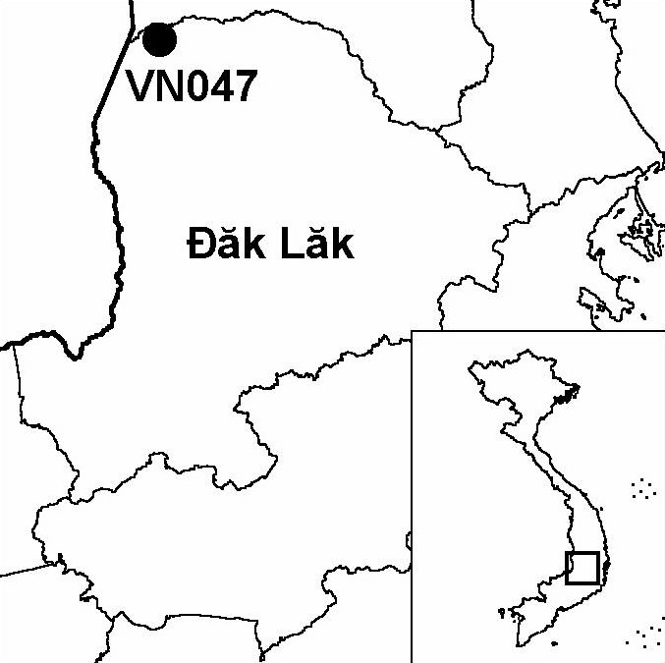
Province(s): Dak Lak
PA Status: None

Latitude: 13º19'N
Longitude: 107º43'E
Area: 30,000 ha
Altitude Range: 100-711 m asl

EBA / SA:

None
Priority Landscape:
DF4 - Eastern Plains Dry Forests

General Description

The IBA is situated in the Mekong basin, along the international border with Cambodia. The IBA comprises an area of relatively undisturbed natural habitat bounded by the Ya Lop river in the north and the Ea H'Leo river in the south. The boundary of the IBA is defined such that a belt of forest on the southern bank of the Ea H'Leo river is included within the IBA. The topography of the site is mostly flat, although there are a few low hills in the north-east. The major vegetation type at the IBA is deciduous forest, although there are also areas of semi-evergreen and evergreen forest distributed along rivers and streams. One of the most notable physical features of the IBA is the series of ox-bow lakes distributed along the Ea H'Leo river. To the north, Ya Lop IBA is contiguous with Chu Prong IBA in Gia Lai province, while, to the west, it is contiguous with Upper Srepok Catchment IBA in Cambodia.

Bird Fauna: Key Features

Because Ya Lop IBA forms part of a large, contiguous landscape of natural habitats, the potential for the long-term conservation of key bird species at the site is perhaps higher than at other, more isolated, sites. Ya Lop IBA supports some of the most intact stretches of riverine forest remaining in the lowlands of Vietnam. This habitat supports a number of globally threatened and near-threatened bird species, including Grey-headed and Lesser Fish Eagles Ichthyophaga ichthyaetus and I. humilis and Oriental Darter Anhinga melanogaster. Other globally threatened and near-threatened bird species found at the IBA include White-rumped Vulture Gyps bengalensis and Red-headed Vulture Sarcogyps calvus. The former species is globally critically endangered, and currently known from only one other site in Vietnam: Chu M'Lanh IBA. Both species have declined drastically in Vietnam in recent decades, and are now largely restricted to areas along the Cambodian border. Indeed, it is possible that Vietnam no longer supports a breeding population of either species¹. Neither species has been confirmed to breed at the IBA.

Species | IBA  Criteria | Global Threat Status | Other  IBAs | Notes
White-rumped Vulture  Gyps bengalensis | A1, A3 | CR | 1 | A single adult was observed on two occasions in June 1997².
Green Peafowl  Pavo muticus | A1, A3 | VU | 8 | A single individual was seen and feathers of this species were found in June 1997². The species was recorded on numerous occasions during March 1998³.
[Sarus Crane  Grus antigone] | A1 | VU | 5 | During a survey in 1997, loggers reported the occurrence of the species².
Lesser Adjutant  Leptoptilos javanicus | A1 | VU | 7 | Two single birds and a group of three were observed in June 1997². In addition, three single birds were recorded along the Ea H'Leo river in February 1998³.
Lesser Fish Eagle  Ichthyophaga humilis | A1 | NT | 6 | Two single birds, only one of which was identified to species level, were observed along the Ea H'Leo river on separate days in June 1997².
Grey-headed Fish Eagle  Ichthyophaga ichthyaetus | A1 | NT | 8 | A single individual was observed in June 1997². A pair was seen displaying along the Ea H'Leo river in February 1998³.
Red-headed Vulture  Sarcogyps calvus | A1, A3 | NT | 3 | The species was observed on numerous occasions during June 1997².
White-rumped Falcon  Polihierax insignis | A1, A3 | NT | 4 | Four single birds and a group of four were observed in June 1997². A single bird was also recorded in March 1998^{3,4}.
Oriental Darter  Anhinga melanogaster | A1 | NT | 9 | A single individual was observed along the Ea H'Leo river in June 1997².
Asian Golden Weaver  Ploceus hypoxanthus | A1 | NT | 3 | The species was observed in small numbers on numerous occasions, and three nests were seen under construction, during June 1997².

Notes: [ ] = unconfirmed record.

Biome Restricted Species: The site qualifies under criterion A3 because it supports 20 species restricted to the Indo-Malayan Tropical Dry Zone (Biome 11). See Appendix 4 for details.

Secondary Criteria

Species Status Species Status
Northern Pigtail Macaque Macaca leonina² VU [Brow-antlered Deer Cervus eldii]² VU
[Stump-tailed Macaque Macaca arctoides]² VU Gaur Bos gaurus² VU
[Douc species Pygathrix sp.]² DD/EN Banteng Bos javanicus² EN

Notes: [ ] = unconfirmed record.

Threats to Biodiversity

Ya Lop IBA is currently under the management of Ya Lop State Forest Enterprise, and significant areas of forest within the IBA have been subjected to commercial logging in the past. The results of a survey in 1997 revealed that the impacts of logging on the condition of the natural habitats at the IBA did not appear to have been too severe, and the riparian forest along the Ea H'Leo and Ya Lop rivers remained in a largely good condition². However, the situation may have changed significantly during the intervening five years.

The major threat to biodiversity at Ya Lop IBA is the rapid spread of human settlements and associated agricultural expansion along the Ya Lop and Ea H'Leo rivers. Apart from the direct loss of habitat, the increase in human population in the area can be expected to lead to greater pressure on the natural resources of the IBA, through timber extraction, NTFP collection, livestock grazing, fishing and hunting². Patterns of human settlement within the IBA follow logging roads and water courses, and, consequently, future road developments within the IBA must be considered as a potentially serious threat.
Threat | Severity
Agricultural intensification / expansion | ● ● ●
Aquaculture / fisheries | ●
Commercial timber extraction | ● ●
Forest grazing | ●
Hunting | ● ●
Infrastructure development | ● ●
Selective logging / cutting | ●
Unsustainable exploitation of NTFPs | ●

Conservation Actions

- None to date.

Recommendations

- The boundaries of Yok Don National Park should be extended northwards to the border with Gia Lai province, thereby incorporating Ya Lop IBA, and linking Yok Don to Chu Prong proposed nature reserve^{2,3}.
- A network of guard stations should be established and patrols should be created to provide a basis for enforcement of forest management regulations at the IBA.
- Concerted action should be taken to halt the spread of human settlement and agriculture along the Ya Lop and Ea H'Leo rivers, and other areas within the IBA.
- Environmental Impact Assessments should be conducted prior to any future infrastructure developments at the site, particularly those involving road construction, and appropriate mitigation measures should be implemented.
- A detailed threat assessment should be conducted to collect up-to-date information on the nature and severity of threats to biodiversity at the IBA as a basis for conservation action.

References

1. Eames, J. C. and Tordoff, A. W. (in prep.) Recent records and a conservation status review of some threatened and near-threatened bird species in Vietnam.
2. Le Xuan Canh, Pham Trong Anh, Duckworth, J. W., Vu Ngoc Thanh and Lic Vuthy (1997) A survey of large mammals in Dak Lak province, Vietnam. Hanoi: WWF Indochina Programme and IUCN.
3. Brickle, N. W., Nguyen Cu, Ha Quy Quynh, Nguyen Thai Tu Cuong and Hoang Van San (1998) The status and distribution of Green Peafowl Pavo muticus in Dak Lak province, Vietnam. Hanoi: BirdLife International Vietnam Programme.
4. N. W. Brickle, in litt. 2002.

